Samplitude Hardware Controller Mapping – Pro X2 & Pro X3
October 26, 2016 by Terry Britton
I am about to make a video showing how I set up my Akai MPK249 and Alesis QX49 controllers, as well as the knobs on my Kawai K5000 additive synth and the sliders and buttons on my Peavey PC1600x controller box to control various settings in both the mixer and within plugins.

Before I do, here are my notes – the outline thus far. I would appreciate any suggestions for improvements to these before I commit this all to a video format!

Samplitude Hardware Controller Mapping
First, hit “Y” to get to the settings, then click “Hardware Controllers” and once there on the Basic Settings page, add the controller as a new controller by clicking “Add New”, choosing “New” from the list (or perhaps a preset if you have an included controller), select its input (and output if it can react to messages sent to it) and use Save As to give it a name. All done here.

On the Options page, set things up as follows:

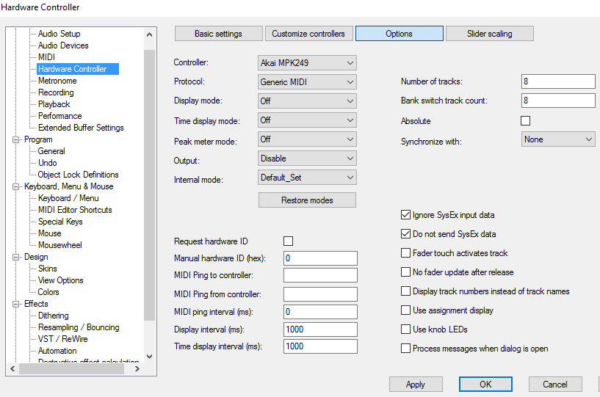
Protocol = Generic MIDI
Internal Mode = Default Set
Tracks = 8
(for most controllers, equals number of sliders. Arturia Keylab series would use 9.)

Bank Switch Count = 8
(for most controllers, equals number of sliders in each bank. Arturia Keylab series would use 9.)
Output to Disable
Display Mode, Time Display Mode, Peak Meter Mode all to OFF
Check Ignore Sysex Input Data
Check Do not send Sysex Data
Un-Check Use Assignment Display
Un-Check Use Knob LEDs

Now to the Customize Controllers page. We are going to use the “Hardware Controller Easy Learn” process to add our controllers. Note: The manual does not, at the time of this video, show the “MIDI Learn” checkbox. This is not needed for the “Hardware Controller Easy Learn” approach to add controls from the Mixer, but it MUST be checked to use the Hardware Controller Easy Learn from any plugins for that menu item to appear as “checked” and work at all. You can check that box now, and then close the Hardware Controllers dialog for the time being, as we will be first working with the Mixer.

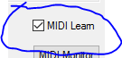

The following image shows a Mixer menu with Hardware Controller Easy Learn enabled. Show this menu by either right-clicking the mixer menu bar or by left-clicking the system icon on the left of the mixer, or for plugins by clicking the word “Plugin”. This item will already be checked if you have “MIDI Learn” checked in the Customize Controllers page (required for plugins). You can still access it here in this menu to un-check Hardware Controller Easy Learn in order to terminate the selection and the controller adding process.

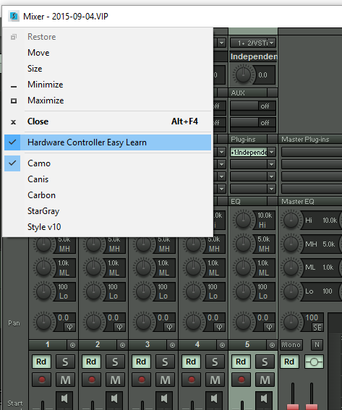
Again, you do NOT actually need MIDI Learn checked to assign the Mixer controls – that only applies to plugins. Also, you can simply add all of your controllers without assigning them to anything from within the Hardware Controller “Customize” dialog by checking the MIDI Learn box and just moving each controller. Then you can assign them later using the “Select Function” box or by using Easy Learn.

With Hardware Controllers Easy Learn checked, you move the screen item you want controlled first, then move the physical controller, and in a few seconds turning the knob or moving the slider will work to move the screen item. If it is not working with certain sliders or knobs, see “If you have some incorrectly sensed items” a little ways down below.

Now enter the Customize Controllers page and you will see in the Easy Learn column on the right all of the assignments that actually worked. Click the title “Easy Learn Function” to sort them, and shift-click to select all the ones having assignments, and then right-click on those and select “Adopt Easy Learn Function” to make it permanent.

BEFORE:
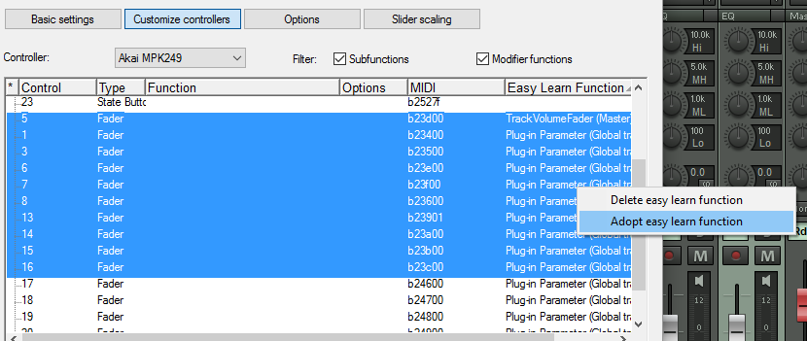

AFTER: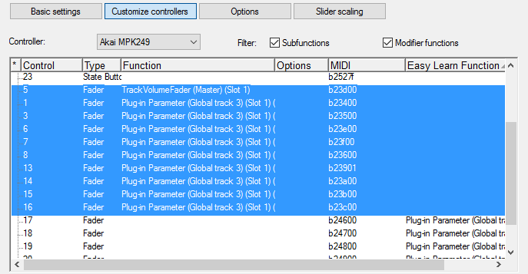

Although you have now created some “permanent” assignments, you can use to same “Easy Learn” technique to assign temporary replacements of different items controlled with the same physical controllers, like a plugin, for instance. You can remove individual temporary “Easy Learn” assignments via a right-click (“Delete Easy Learn Function”), or go into the Options page and hit “Restore Modes” to clear them all in one swoop.

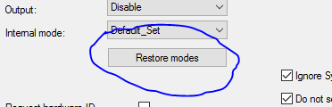

If you have some incorrectly sensed items, right-click in the offending control’s “Type” column and select the correct one from the list. Usually the mis-identified ones are sliders or knobs mis-identified as buttons. Simply assign “Fader” in most cases. There are also assignments for two kinds of knobs available, “Absolute” for knobs having a bottom and top position, and “Relative” for encoder-type infinite turn knobs.

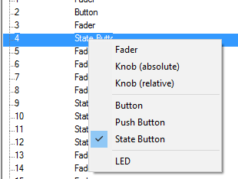

My Akai’s buttons are mostly “toggle” style, meaning they send 127 when pressed the first time and zero when pressed the second time, which Samplitude calls a “State Button”. It also can be set to send a “momentary” button press, which sends a 127 when pressed and a zero when released, which Samplitude calls a “Button”. The third kind of button Samplitude can assign is called a “Push Button” – a button that sends a signal when pressed but nothing when released.

Of the knobs and sliders, make sure the knobs and sliders are set on your physical controller to “Controller” for output, and not to “Inc/Dec”.

Lastly for this video. most of your controls will want to be set to “Global track”.

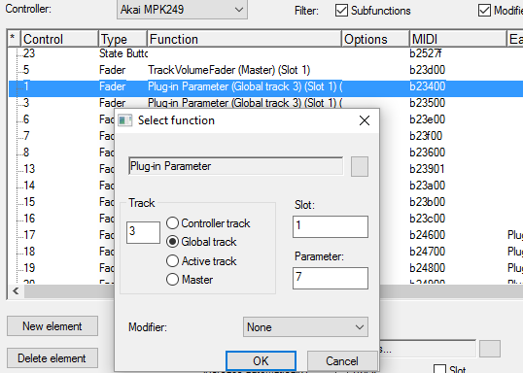

“Active Track” will allow one set of controllers that will work on the selected track upon whichever control item is in that same “slot” or position.

Items like the Master Volume and Monitoring Volume will be of the “Master” type.

This part I am not entirely clear about:
If you use the “Controller Track” type shown above the others, you can change the assignments between “Mixer” and “Active Track” from the Options page.

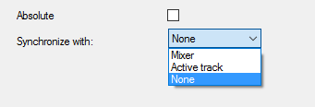

Synchronize with Active Track: If the active track is changed, the controller area will be adjusted so that the active track is within the controller area.

Synchronize with Mixer: If a change is made to the controller area, the beginning of the mixer area will be adjusted according to the beginning of the controller area.

Also, I could not find any reference in either the Pro X2 or the Pro X3 manual as to what the “Absolute” checkbox shown in the image above actually does.

The biggest “gotcha” for me that was not clear in the manual was that you needed to check the “MIDI Learn” checkbox before the dropdown “Plugin” menu at the upper-left of any plugin would allow me to select the “Hardware Controller Easy Learn” item. (True in both Pro X2 and Pro X3.)
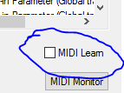

Also, the manual does not actually SHOW the “MIDI Learn” checkbox at all, nor is there any mention of it that I can find.

The other major “gotcha” was the unexpected situation of the “Hardware Controller Easy Learn” mis-identifying only CERTAIN knobs and sliders as being buttons. One needs to fix that right away for them to be useful, of course, but at least this IS mentioned in the manuals.
The Hardware Controller section of the manual begins on page 445 of the Pro X3 manual, but is on page 498 of the Pro X2 Suite manual, while it is on page 360 of the Pro X manual I downloaded. (Check the table of contents under “Hardware Controllers” for your version of Samplitude if not found on those pages…)

(I just discovered that this same approach is what is necessary to make the Transport buttons work on a Native Instruments (NI) S-Series Komplete Kontrol controller as well.
After setting it up as a General MIDI item (not as a Mackie Universal Control as NI would have you believe), just use MIDI Learn with each transport button and assign from the list as shown above.)

